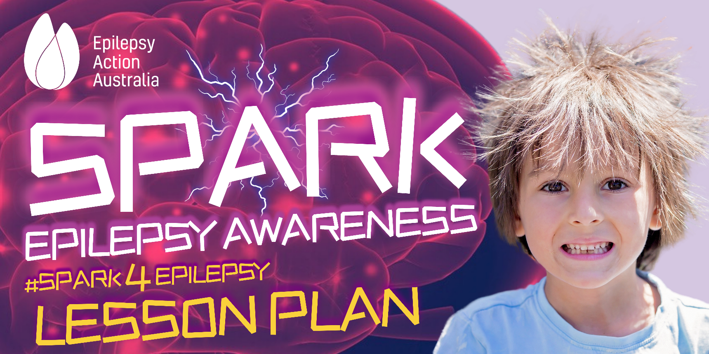

OBJECTIVE
This lesson plan is designed to;
- Introduce students to understand the concept of static electricity.
- Investigate how rubbing a balloon on hair generates static electricity by engaging them in a hands-on experiment.
- Observe and describe the effects of static electricity.
- Spark a conversation about epilepsy by identifying and understanding the electrical activity of neurons in the brain, how seizures happen and how to break the stigma associated with epilepsy.
DURATION
45-60 minutes
- Wool cloth (optional, for comparison)
- Scissors
- Tape
- Table or desk

MATERIALS
- Balloons (at least one per student or group)
- String (for suspending the balloon)
- A small piece of paper or tissue
- Hair (student volunteers with various hair types)

INTRODUCTION (10 MINUTES)
- Begin the lesson by discussing what students already know about electricity.
- Introduce the concept of static electricity as a type of electricity that doesn't flow like the electricity in wires but can cause interesting effects.
- Explain that today, they will learn about static electricity through a hands-on experiment using balloons.
ACTIVITY - RUBBING BALLOONS (10 MINUTES)
- Divide the class into pairs or small groups and distribute balloons, strings, scissors, and tape.
- Instruct each group to cut a short piece of string (about 30 cm) and tape it to the end of the balloon.
- Have students blow up their balloons slightly and then tie a knot at the end of the string, creating a "balloon on a leash."
- Ask each group to rub their balloon vigorously on their hair for about 20 seconds and then hold it 30 cm away from their head to observe what happens.

1. Divide the class into pairs or small groups and distribute balloons, strings, scissors, and tape.

- Encourage them to make observations about the behavior of the hair when the balloon is brought close to it.
- Have groups compare their observations and discuss what they think is happening.
DISCUSSION & EXPLANATION (10 MINUTES)
- Bring the class back together and ask students to share their observations.
- Explain that when they rubbed the balloon on their hair, they were transferring electrons from their hair to the balloon, creating a charge imbalance.
- Discuss how opposite charges attract and like charges repel. The negatively charged balloon attracted the positively charged strands of hair.
- Optionally, demonstrate the same experiment using a wool cloth instead of hair to show that different materials can generate static electricity.

EPILEPSY EDUCATION & AWARENESS (15 MINUTES)
- Bring your class back together to spark the conversation about epilepsy and dispel any myths they may have about the condition.
- Start off the conversation by asking students what they think epilepsy is and how it is caused. {ANSWER} The brain is made up of millions of nerve cells called neurons. Just like static electricity causes interesting effects, these neuron brain cells generate electrical impulses and messages to produce thoughts, feelings, sensations, movement, and control body functions. Epilepsy is a neurological disorder that affects more than 250,000 Australian’s. When there is a temporary disruption of the electrical activity in the brain, a seizure may occur.
- Continue the conversation by asking students what they would do if a peer had a seizure? Once students have given their responses, click on this link https://vimeo.com/281534395 and share this short, animated video of Seizure First Aid with the students. This video has been created specifically to educate staff and students within schools.
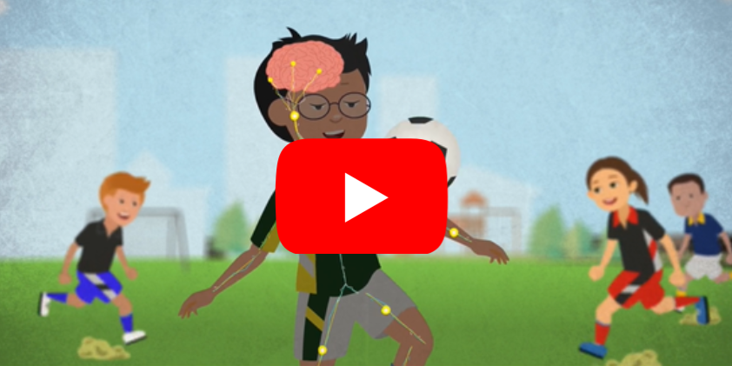

CONCLUSION (5 MINUTES)
- Summarize the key points about static electricity, its generation through rubbing, and how opposite charges attract.
- Remind students to record their findings and observations in their science journals.
- Encourage students to explore static electricity further on their own or with additional experiments.
- Encourage students to further explore epilepsy and remind them that every school has a duty of care to provide a safe learning environment, and to ensure they meet the needs of every student, including those who have epilepsy. It is important for them to be able to recognise a seizure and the appropriate first aid to respond to it.

